 C:\Users\Philip\AppData\Local\Microsoft\Windows\Temporary Internet Files\Content.IE5\DIPBL175\MC900089034[1].wmf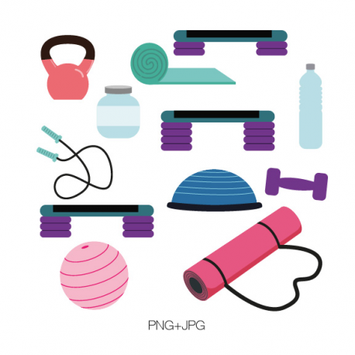

Hi Girls, how are you? Can you believe its already March! It’s crazy how fast the winter is going and before you know it will be time to go back to camp! We are excited to be returning to The George School. Many of our key staff are returning to camp for what will be an unbelievable summer. Let’s say goodbye to winter and get back into our summer routines.  
  
Remember, its all about a lifestyle change. Our head nutritionist, Torie Kuebler, is back with her nutrition team and is already planning great rap session topics, cooking classes, and the one-on-one counseling sessions. We Remember, the things we cover in camp are changes that will carry over after camp and not only throughout the year, but the rest of your lives! All of our key staff are back this year! Nikki Ruane and Margaux Babalian as head counselors. Group leaders include Katie Hoover, Alyssa Granger, Suni Sharma. Jet staff include Estefania Guzman (4th year), Daphney Milord (10th year), Julia Sochin (9th year), Rachel, Heather, Vany and Erica P (3rd year). Returning specialists include Michelle (boot camp), Cheryl (arts & crafts), Dawn (camp mother – 14th year), Cindy (camp administrator/driver – 2nd year). We truly are a family at Camp Pennbrook with most of our staff home-grown!  
We also have many new and exciting activities and listed in this newsletter are the amazing trips already lines up for this summer. We can’t wait to see you this summer!

# Hello!

Attention new parents and campers!!! Be sure to set aside one of the following dates when you can tour the beautiful facilities of Camp Pennbrook and meet most of our key staff members and new campers. Refreshments will be served.

Save the date: **April 23rd** or **May 21st!** **12-4 PM**

For questions or concerns don’t hesitate to contact us. Please RSVP today by calling 1-800-442-7366 or email Camppennbrook@att.net.

This summer we have started to line up the best tours out there. Campers will have a chance to go to:

**ED SHEERAN 7/11 and 7/12**

Please let us know if you see any other concerts we should go to this summer! Don’t forget to sign up for camp to reserve your spot for the show! Tickets are limited.

## Summer Concerts

## Open Houses

Camp Pennbrook March Newsletter

March 2017

## Returning Staff

One of the things that makes Camp Pennbrook the special place that it is are the amount of returning staff we have each year. Not only are most of our key staff and group leaders back this summer, but many former campers are now going to be counselors and are part of our "home grown” camp family. So far, planning to return are our group leaders, Suni Sharms, Nikki Ruane and Joanna Mattaliano. Torie Keubler will be heading our nutrition team, and so far we have heard from Erica Calhoun, Chelsea Carter, Alyssa Granger, Alex Woody, Julie Sochin, Daphney Milord, Mamma Goose and Dawn Ormes. Our cardio team has Kate coming back along with Mike and the George School staff.

## Verbal Ase Comes to Camp Pennbrook / Beat Boxing

We just returned from the annual Camping Conventions and booked the hottest new evening activity. We are pleased to introduce Verbal Ase, a very talented Beat Boxer whose specialties includes performing voice impressions, extraordinary sound effect with DJing live music to go with dazzling visual display.

Verbal Ase has made a name for himself by commingling his specialism of beat boxing, voice impressions, and comedy along with current trending music. Social media has helped increase his fan base along with his dedication to providing his audience with a full-fledged entertainment set. Past appearances include Madison Square Garden halftime show at a NY Knicks game, Showtime at the Apollo and the Steve Harvey Show!

Check out his website verbalaselive.com.

## Broadway

This summer we are going to Broadway’s top hits. Campers will get a chance to see “Charlie and the Chocolate Factory” on 7/2 and “Hello Dolly” with Bette Midler on 7/30. They both will be great shows!

This summer we are excited to have Tori Kuebler back as our registered dietician on campus. This will be Tori’s fourth summer at camp and she couldn’t be more excited. She will be running the weekly RAP classes along with re designing the new course.

Tori is really excited to work with each and every one of you and help you learn all the valuable tools you need for your weight loss journey.

Campers will get to learn about our camp meal plan and why it works, they will also learn how to properly balance meals at home as well as choosing wisely when it’s time to snack. These are just a few of the topics that will be covered.

We can’t wait to see what Tori will be teaching.

## Dramatics: “The Big Show”

We are already starting to get suggestions for this year’s big show. Last year we did “Annie” and in prior years we have done “Hairspray”, “The Little Mermaid” “Charlie Brown” and “Bye Bye Birdie” So far the suggestions we have are “The Wizard of Oz”, “The Sound of Music”, “The Lion King” and “Aladdin”. Email or call us with your ideas our upcoming summer production!

## Summer Activities

This summer is shaping up to be a great one. We have already booked some of your favorite activities:

* Game show Man
* Karaoke/ dance parties
* Bowling / Laser Tag
* Movies at the Multiplex
* Eric Wilzig Magic Show
* Ice Skating
* Beach
* Day at the Beach at the Jersey Shore

We are still looking for new activities and entertainment to make sure each and every one of you has the best time at camp.

Feel free to email us any ideas or activities you would like to see at camp!

## New RAP Sessions with Tori

We still have limited openings for current and alumni campers who would like to be CITS (Counselors-in-training) or JCs (Junior Counselor). These are the training programs for becoming a full-fledged counselor. You must be 15 or 16 to be a CIT and 17 or 18 to be a JC. CITs can attend for 3 weeks or longer but JCs must attend for either 4 weeks or the full 7 weeks. Both positions involve a great deal of responsibility and also afford you a reduced tuition. You would still have a chance to work out everyday and participate in all the sports and activities. Call for details.

## Junior Counselor and Counselor-in-Training

-Try to get at least 30 minutes of cardio in today! Dedicate these 30  
minutes to yourself and your health.  
  
-When you feel like giving up, simply look back on where you started  
and how far you have come. It's all worth the work!  
  
-Tired of the same workout routine? Try something new to keep you  
interested and moving. Research new workouts online, ask a personal  
trainer, or follow exercise accounts on Instagram for inspiration of  
new workouts to try.  
  
-Cardio and strength training are BOTH important. Try your best to  
incorporate both into your workout routines.

**We are pleased that Michelle will be back with her great Boot Camp and we are delighted to introduce our new Zumba instructor, Gabby Mason. Gabby is from Ohio and currently attends the University of Kentucky. She can do body blast, upper and lower body and can teach volleyball and also will teach Zumba Water Aerobics.**

## March Workout Tips!