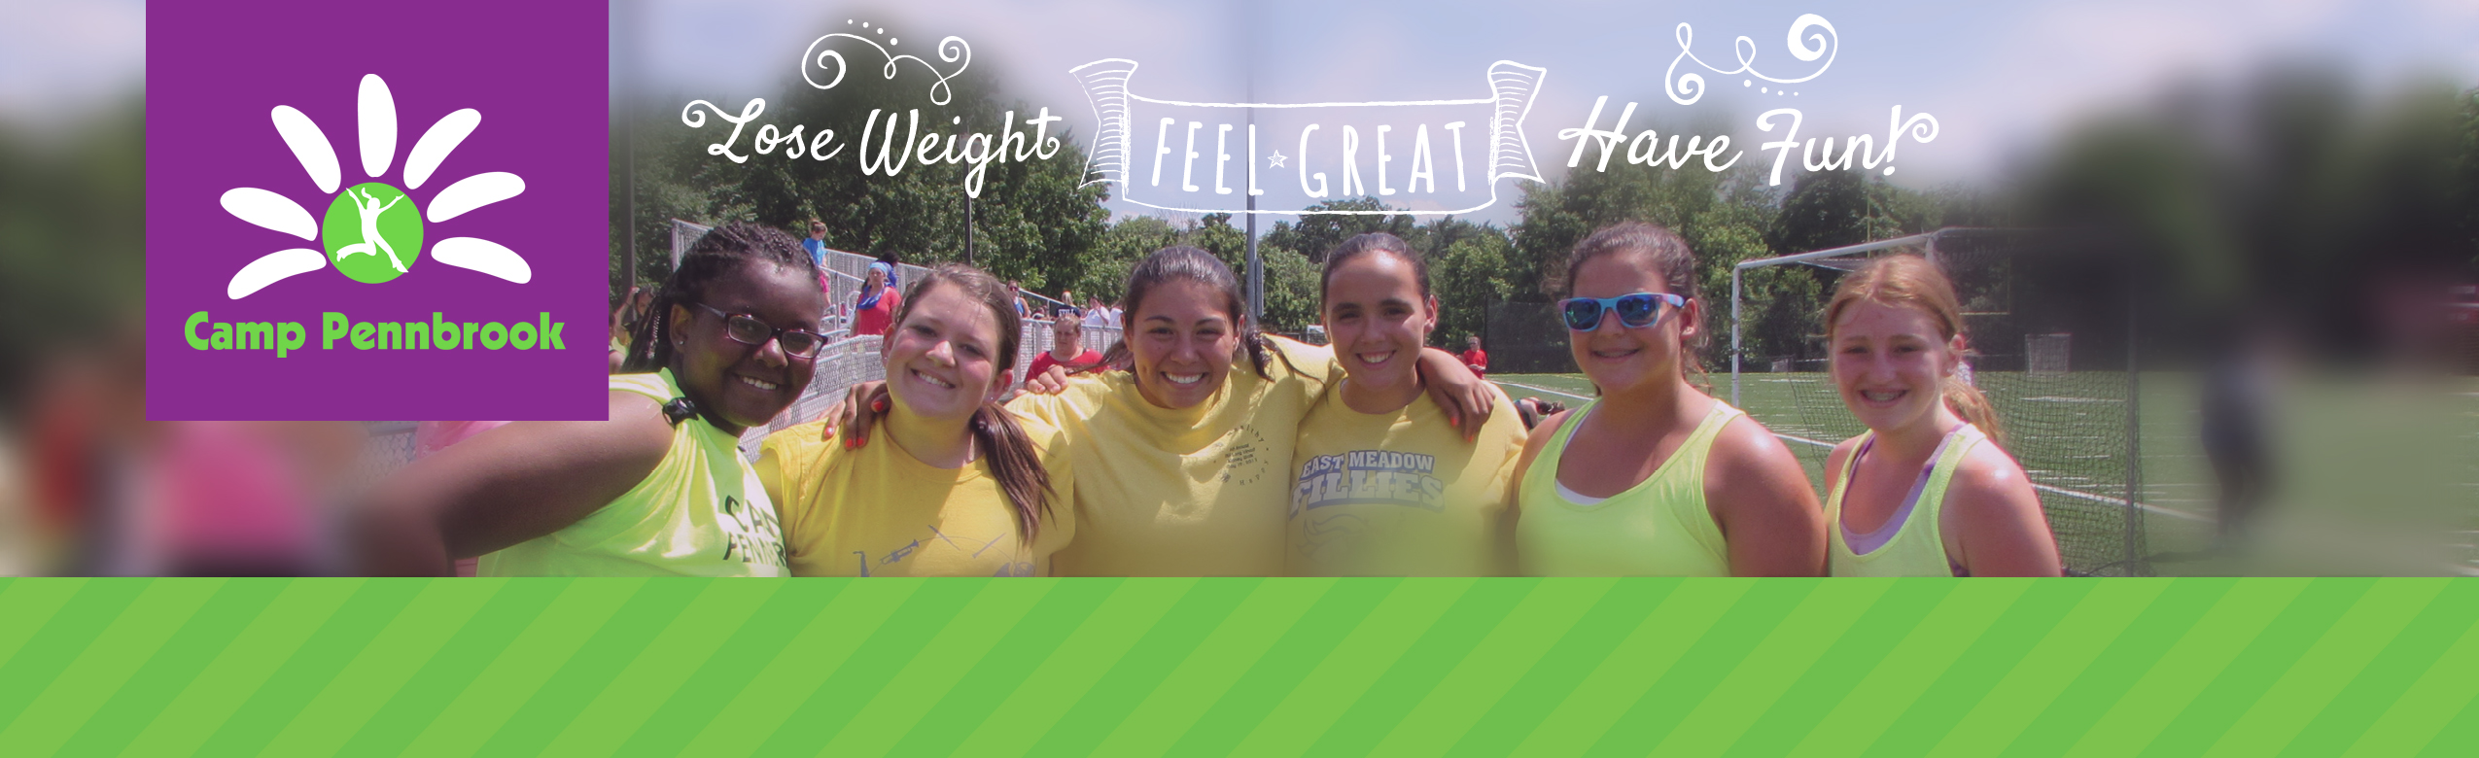**Camp Pennbrook April 2017 Newsletter**

# A Note From Our Directors

Upcoming Events

Open House

April 23rd and May 21st

**Opening Day**

June 24th

## Open House

Attention new parents and campers!!! Be sure to set aside one of the following dates when you can tour the beautiful facilities of Camp Pennbrook and meet most of our key staff members and new campers.

Refreshments will be served. Save the date for: April 23rd or May 21st!

For questions or concerns don’t hesitate to contact us. Our 2016 campers are invited as well. Please RSVP today.

800-442-7366

212-354-2267

camppennbrook@att.net

Spring is here, the flowers are starting to bloom…and that usually means that as we move into a new season let’s try to focus on ourselves and our goals. Setting up a smart and realistic goal will be great motivation to stay on track. Always remember we are in control of our decisions and in order to stay on track we must want it in order to achieve it! Most of our key staff are returning and have been working hard this winter to provide you with a great summer. We have some unbelievable trips and some new and exciting activities already planned.

See you soon!

Flip, Nikki, Margaux, Suni, Alyssa, Katie

# Summer Trips

The summer of 2017 is shaping up to be jam packed with exciting trips. We already have planned out our nights at the movies, mini golf, ice skating, beach days and bowling nights.

Campers will get to go to Dorney Park, Six Flags, NYC Shopping trip, Whitewater rafting, NYC tour, “Hello, Dolly” on July 30th and “Charlie and the Chocolate Factory” on July 2nd on Broadway and King of Prussia Shopping trip.

Once again we have an exciting concert lineup for the summer. This year’s shows include Ed Sheeran on July 11th and 12th and we are looking for more artists to add soon!)! Keep in mind that if you want to attend you must sign up as tickets are limited.

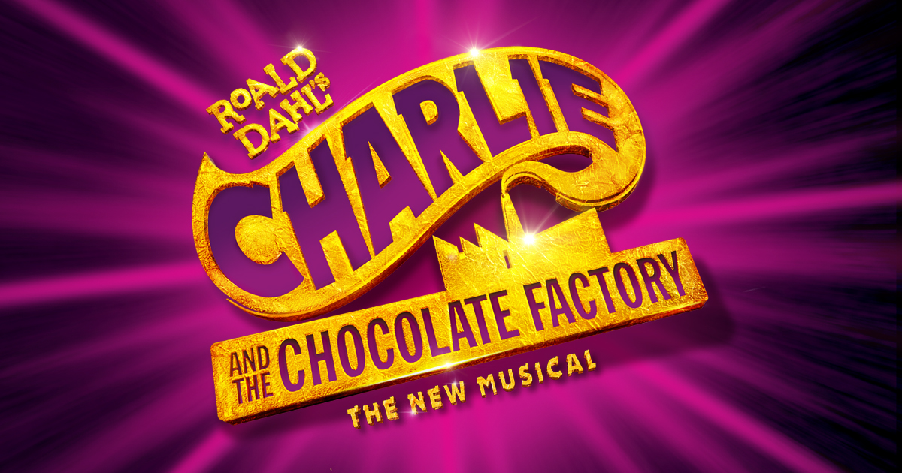



# Follow us on Social Media

Girls make sure to LIKE our Facebook page. It is a great forum for everyone to keep in touch and share recipes, workouts as well as inspirational quotes! Invite your friends and family members as well.

Check us out in Pinterest as well. We have found many wonderful pins related to nutrition, exercise and healthy living. We love all these pins and so will you.

Follow us on Instagram for good inspirational pictures as well as awesome Throwback Thursdays.

We have a great weekly blog on our website which features nutrition articles and recipes!

# A Letter from Tori, Our Dietician

To all my camp people,

Yeah next summer, here we come! I can't believe we're already a couple months into 2016 and camp will be starting so soon! I've been working hard since the end of camp last year to bring the camp's nutrition program to above and beyond the next level. We're going to be introducing some new faces to the nutrition team this summer. You can look forward to new menu items including the addition of a fruit bar on Sunday's during brunch. Cooking class is being revamped with all new recipes that will coordinate with a new take home menu plan, so you're able to use those cooking skills after camp is over. RAP class will be introducing new lessons on snacking, fad diets, while reviewing MyPlate and a balanced diet. And of course, bringing in more nutrition night activities in addition to the popular supermarket tours and Master Chef.

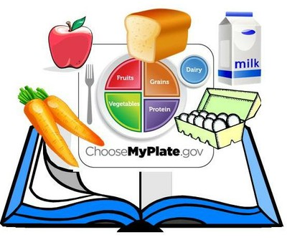Remember, you can reach out to me anytime during the year to ask me nutrition questions... just remember to ask how my day is going first!

See you soon!

Tori Kuebler, RDN, LDN

# 

# Returning Staff

We are truly a family at Camp Pennbrook. Most of our key staff have been with us for many years and most of our counselors are "home grown"--who started with us as campers as young as age 9. This year our Co-Directors will be Nikki Ruane and Margaux Babalian. They have each been with the Camp Pennbrook for family for at least five years, both as counselors and group leaders. In addition, all of our group leaders are former campers. Right now planning to return are  
Katie Hoover, Teens, 4th year  
Alyssa Granger, Debs, 5th year  
Suni Sharma, Seniors 4th year

In addition, Tori Kueber is back for her 4th year as Registered Dietitian. Our boot camp instructor is Lucia Caneiro and our new Zumba instructor is Gabby Mason. Some of our counselors and specialists include Julia Sochin (7th year), Daphney Milord (10th year) Dawn Ormes (15th year), Cindy Argow (2nd year), Estefania Guzman (3rd year), Amanda Bancalari, Elizabeth Lopez, Vanny Scueble, Rahel Aleign, Heather Burns, Erica Pramer, Jessica Russo, Hannah Hollie and Sarah Butler. One of our nurses is Debbie Knispel, whose daughter is Savannah, back for her second year.

# SPECIAL SERVICES: Private Tennis/ Horseback Riding/ Personal Training/CBT Counseling

Once again Camp Pennbrook will be offering additional services for those campers that are interested.

Marc will be returning for his 4th summer at camp to teach semi private and private tennis lessons.

This year at The George School we have the horse stables on site. Campers may enroll on semi private rides as well as private rides.

The George School Personal Trainers will be providing training services for those campers that are interested. Sessions will be semi private as well as private.

Campers will now have CBT sessions (cognitive behavior therapy) with Dr. Janice Jenkins weekly. Janice will also be available for optional private counseling sessions.

# Upgraded Menus and Recipes

Back this year will be everyone’s favorite meals: our Sunday brunches featuring waffles or French toast, BBQ night featuring hamburgers or hot dogs, pizza day, mac & cheese, chicken fajitas and more! CulinArt stands at the forefront of sustainability practices in the school environment, always highlighting local and/or organic produce offerings and other sustainable options throughout the dining hall.

# Camp Store:“Be There or Be Square”

We already started to order new merchandise for our camp store this summer. So far we are planning to order tank tops, long sleeve, hoodies, sweat pants, back packs, water bottles as well as pinnies. Let us know if you have any merchandise you would like to see at the store. So far campers have suggested: pajama pants, soffe shorts, sunglasses and blankets!

# 

# 

# 

# Private Tutoring

We will again be offering private tutoring by licensed teachers and staff. Campers will be able to sign up for classes to stay current with their studies or to make up a class and receive credit with prior approval from their school. All you need to do is bring your textbooks, study aids and lesson plans and we will take care of the rest. Tutoring generally does not affect any of your daily schedule as it is done during rest hour or free play. Alyssa Granger is back as head of our tutoring program and she tutors for math and reading levels, SAT prep, etc.

# Summer Activities/ Special Events

This summer is shaping up to be a great one. We have already planned some of your favorite activities:

* Beat Boxing
* Game show Man
* Karaoke/ dance parties
* Bowling
* Movies at the Multiplex
* Eric Wilzig Magic Show
* Ice Skating
* Color Run
* Color War
* Zumbathon
* World Cup
* Camper vs Counselors Games
* “Minute To Win It”
* Master Chef
* Carnival
* Day at the beach

We are still looking for new activities and entertainment to make sure each and every one of you has the best time at camp. Feel free to email us any ideas or activities you would like to see at camp.

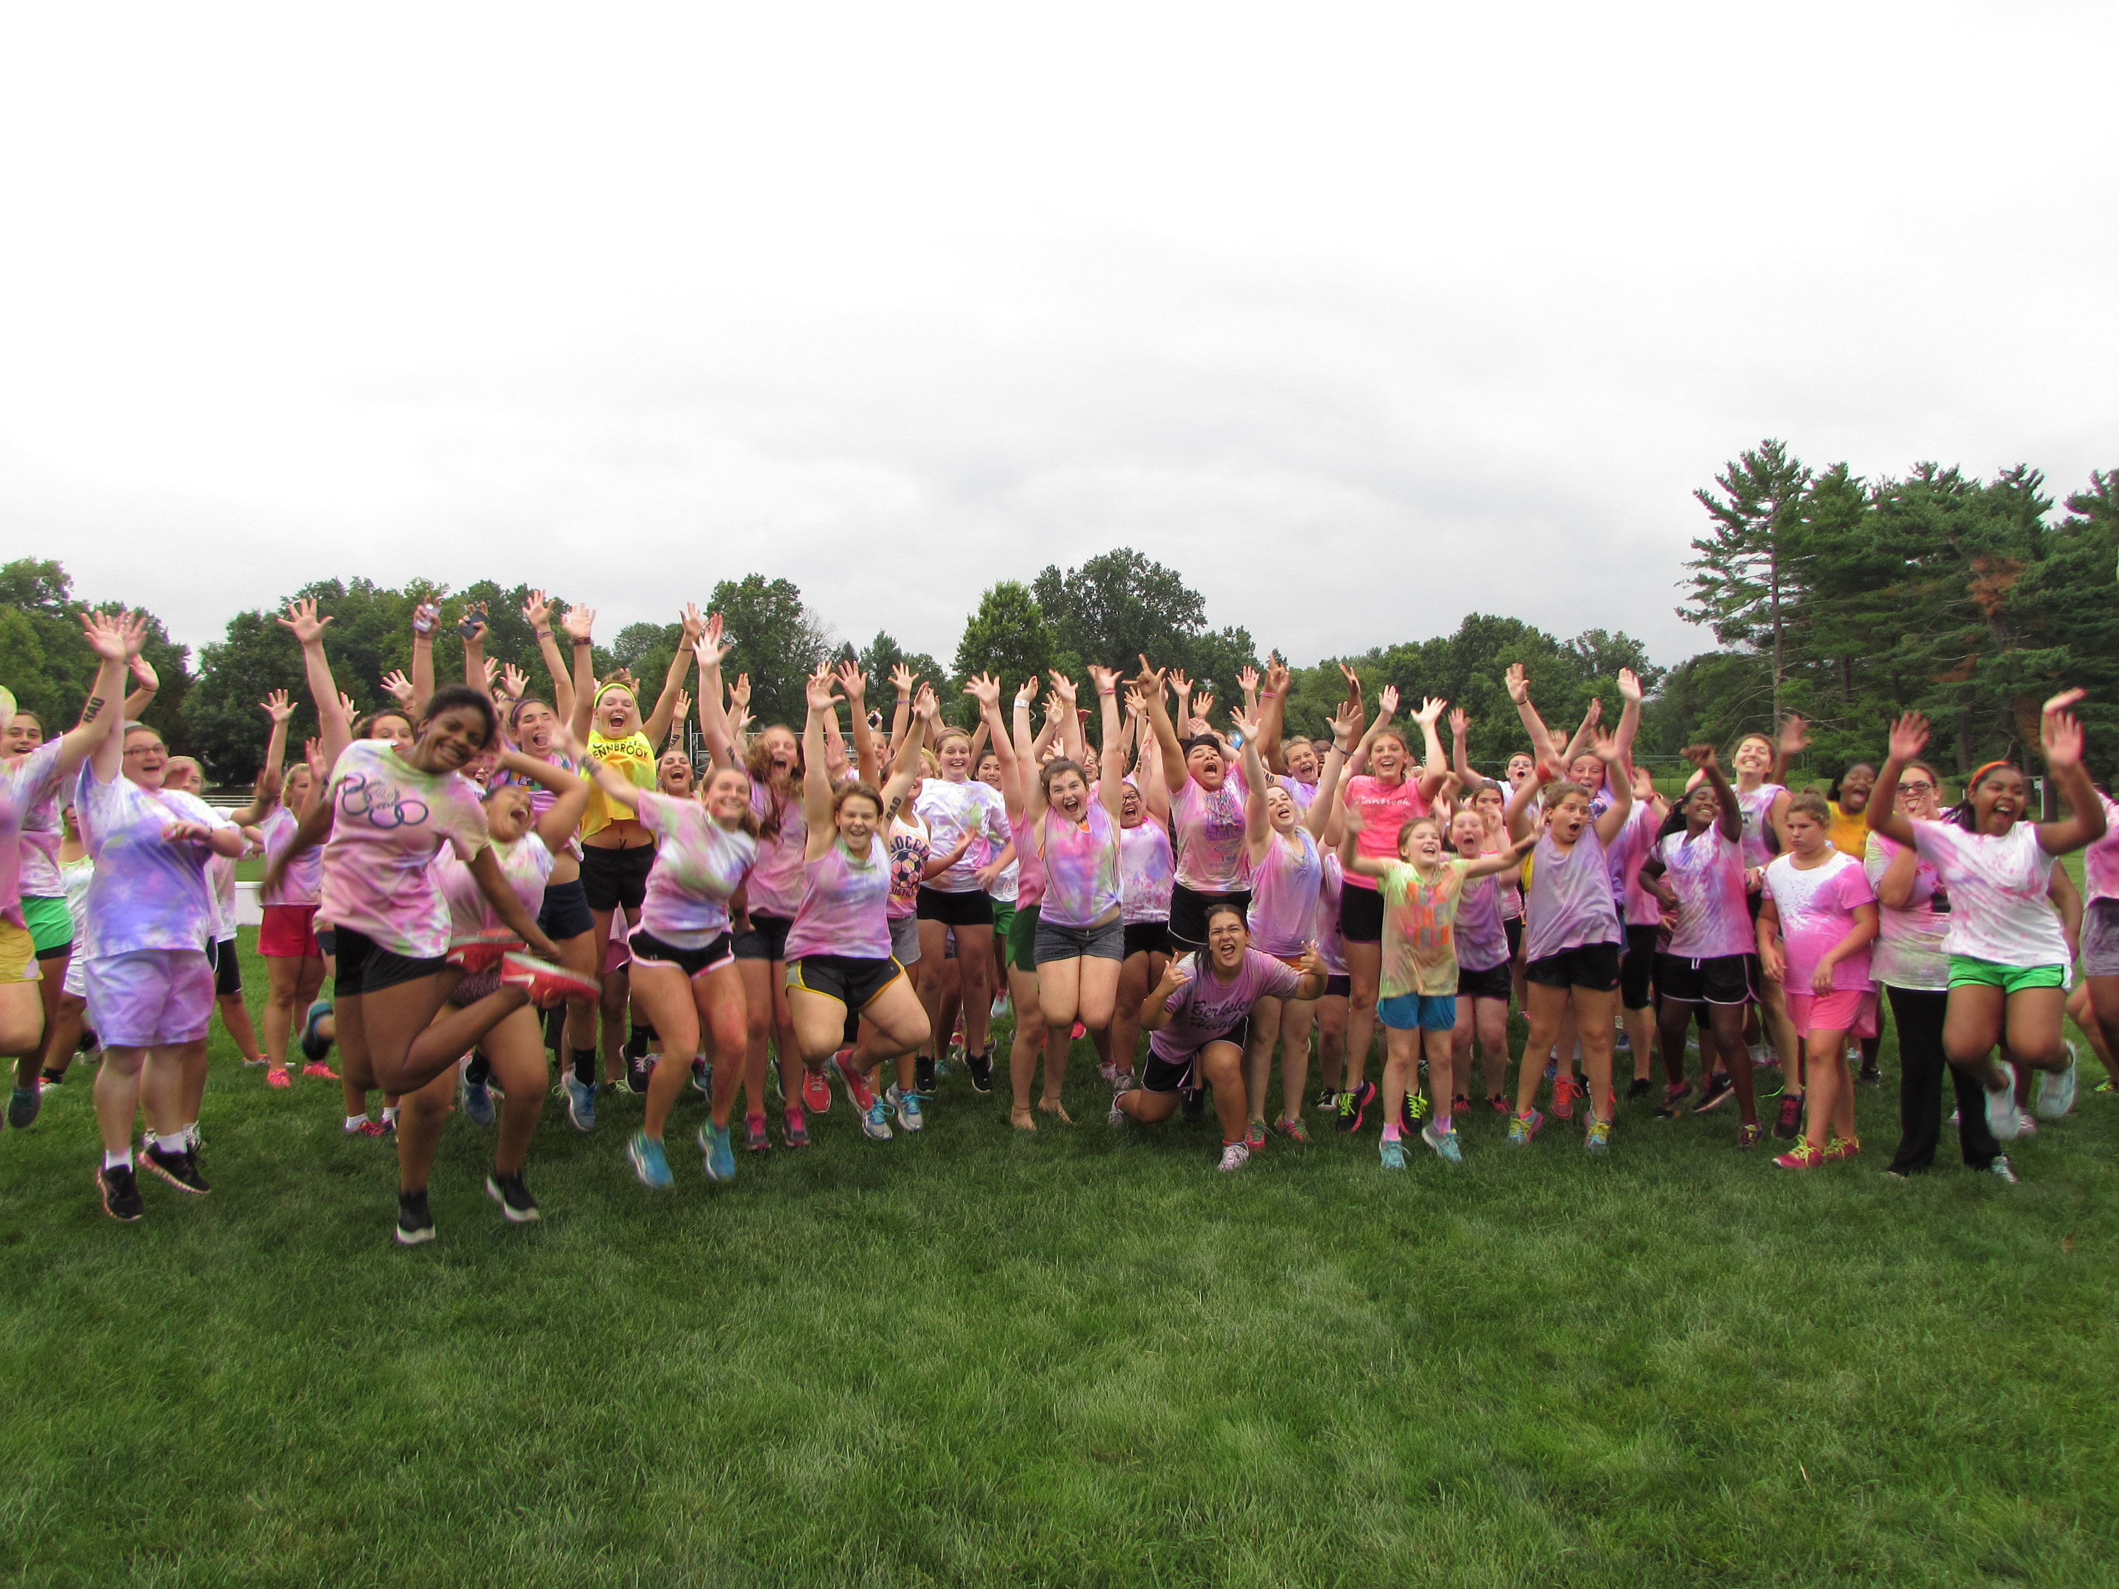

# Weekly CBT Sessions with Janice

We are pleased to welcome Dr. Janice Jenkins as our resident CBT counselor. Janice will have weekly classes with each group to discuss all of their teen age and weight loss issues and concerns. Janice will also be available for private sessions with campers. Your parents may enroll you for 1 or more sessions per week. Janice has a Master of Science degree is social work and is a lean clinician and handles behavioral health services with Elwyn and CATCH agencies and is an independent educational consultant for Academic Transition for Lower School students in Philadelphia. Janice has experience in other weight loss camps and programs. In addition to her group sessions at camp, Janice is always around if a camper needs someone to speak to about any concerns they are having.

# The Big Show

C:\Users\Philip\AppData\Local\Microsoft\Windows\Temporary Internet Files\Content.IE5\DIPBL175\MC900089034[1].wmfWe are already starting to get suggestions for this year’s big show. Last year we did “Annie” and in prior years we have done “Hairspray”, “The Little Mermaid” “Charlie Brown” and “Bye Bye Birdie” So far the suggestions we have are “The Wizard of Oz”, “The Sound of Music”, “The Lion King” and “Aladdin”. Email or call us with your ideas our upcoming summer production!

# Verbal Ase at Camp Pennbrook!

We just returned from the annual Camping Conventions and booked the hottest new evening activity. We are pleased to introduce Verbal Ase, a very talented Beat Boxer whose specialties includes performing voice impressions, extraordinary sound effect with DJing live music to go with dazzling visual display.

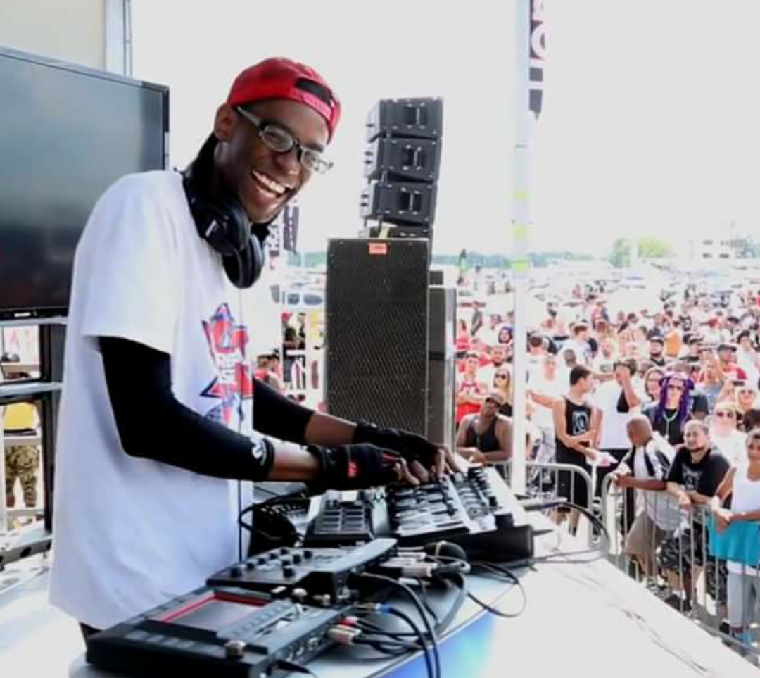Verbal Ase has made a name for himself by commingling his specialism of beat boxing, voice impressions, and comedy along with current trending music. Social media has helped increase his fan base along with his dedication to providing his audience with a full-fledged entertainment set. Past appearances include Madison Square Garden halftime show at a NY Knicks game, Showtime at the Apollo and the Steve Harvey Show!

Check out his website verbalaselive.com.

# Sweet Potatoes Fries Recipe

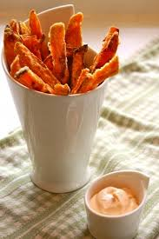  
Ingredients:  
4 medium/large sweet potatoes  
1 tablespoons olive oil  
2 teaspoons garlic powder  
Pepper to taste  
  
Directions:  
1. Scrub and rinse sweet potatoes (leave the skin on to increase the fiber content)  
2. Cut the sweet potatoes into fries, the thinner the fires the crispier they will go!  
3. In a bowl mix the sliced sweet potatoes with the olive oil and garlic powder, stir to coat the fries  
4. Spread fries on a parchment lined baking sheet, bake at 425F for 10 minutes, turn the fries over then bake for 10 minutes on the other side or until nicely browned.  
5. Allow to cool slightly- enjoy!  
  
Try out adding different flavors to your fries- chili powder or paprika both go great!