George School Equestrian Center
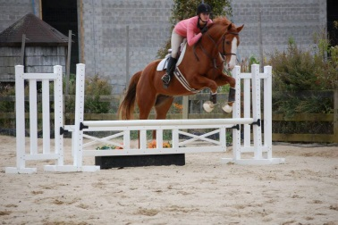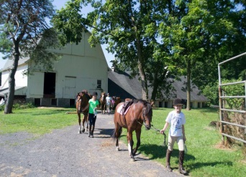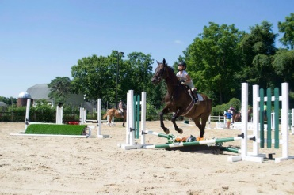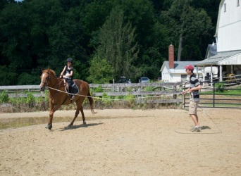
The George School Equestrian Program consists of two all-weather footing rings, 20 exceptional horses, and a staff of equestrian professionals who are devoted to teaching at all levels, from introductory to advanced competitors. George School teaches a “basic balanced seat”, which combines elements of dressage, hunt seat, and jumping. Balance seat teaches the rider body awareness and relaxation so the rider and the horse become a team. Instructors focus on the importance of horsemanship and communication with the horse. Riding instruction is offered for students of all ages, regardless of their experience. Due to the health and safety of both our riders and horses, there is weight limitations of 225 lbs. for riders. However, all participants will be able to learn best horsemanship practices, and horse care techniques. For more information, please contact Tiffany Taylor at 215.579.6710.
Sessions are available Monday through Friday. Campers may ride up to twice a week. The cost is $65 per group lesson. All lessons must be paid for in advance. We require 24-hour notice of cancellation for refunds.
Camper Information
Name:
Arrival Date:____ ___ Check-out Date:_________________
How many lessons would you like a week? Please circle: 1 or 2
Number of Group lessons: @ $65 per lesson
So that we can match riders with the horse that best suites her needs, please complete this portion with the most accurate and up-to-date information.
Age:_______ Height: ft in Weight: pounds
Riding Experience:
Beginner (little to no experience/walk-trot) Intermediate (Walk/Trot/Cater) Advanced (WTC/Jumping)
We accept: check (made out to GSEC), Visa or Master Card (Payment is due at the time of booking)
Name on Card:_______________________ ______________
Credit Card Number:______ ___________________ Expiration Date:____________ Security Code: ________ Total: $___________________

