Camp Pennbrook February 2020 Newsletter
Upcoming Events
Camp Pennbrook Ski Trip
March 8th or 15th
Open House
April 19^{h} and May 17th
Opening Day
June 20th

Open Houses
We look forward to seeing many of our new and old campers at our 2 Open Houses at the George School. They are being held on Sunday April 19th and Sunday May 17th from 12pm to 4pm. Call to RSVP
800-442-7366
212-354-2267
camppennbrook@att.net

NEW FOR 2020:

Health, Wellness & Fitness Programs
Based on feedback we have received from parents and campers, we modified our program for this summer. Our focus in camp and in the rap sessions with the dietitian will deal with fitness, healthy eating, making better choices and learning how to eat healthier. Upon arrival, our nutrition team will assess each camper to see if they will be on the maintenance plan or weight management plan. Most of our girls are more interested in getting into better physical condition and learning to make better food choices. The girls will learn how to eat more well-balanced, nutritionally correct, wholesome organic food. We are just like any regular camp for girls--only better.

2020 Trips
We are busy booking the best trips for the 2020 summer. So far, we have booked:
BROADWAY:
- MRS. DOUBTFIRE
- MOULIN ROUGE
CONCERTS:
- HARRY STYLES
- JUSTIN BIEBER
- MAROON 5

Activities Booked for 2020

THE GAME SHOW MAN

ERIC AND HIS MAGIC SHOW

BOWLING

SATURDAY NITES AT THE MULTIPLEX

ICE SKATING

A DAY AT THE BEACH

CARNIVAL

PAINT RUN

COLOR WAR COMPETITION

WORLD CUP

APACHE RELAY

COUSELOR HUNT

SCAVENGER HUNT

LIP SYNC GAME

NAME THAT TUNE

AND MORE!

JUNIOR COUNSELORS/CITS
We have a large number of returning campers who are now old enough to attend camp as JC's (junior counselors) or CIT's (Counselors in Training). If you are 15 or older and would like to be considering for one of these reduced rate programs please call today. This program prepares you to become a full fledged junior counselor a year earlier. New staff who apply must be age 19 with a year of college. Campers who complete the CIT/JC program may qualify to be counselors by the time they turn 18 and are going into college!
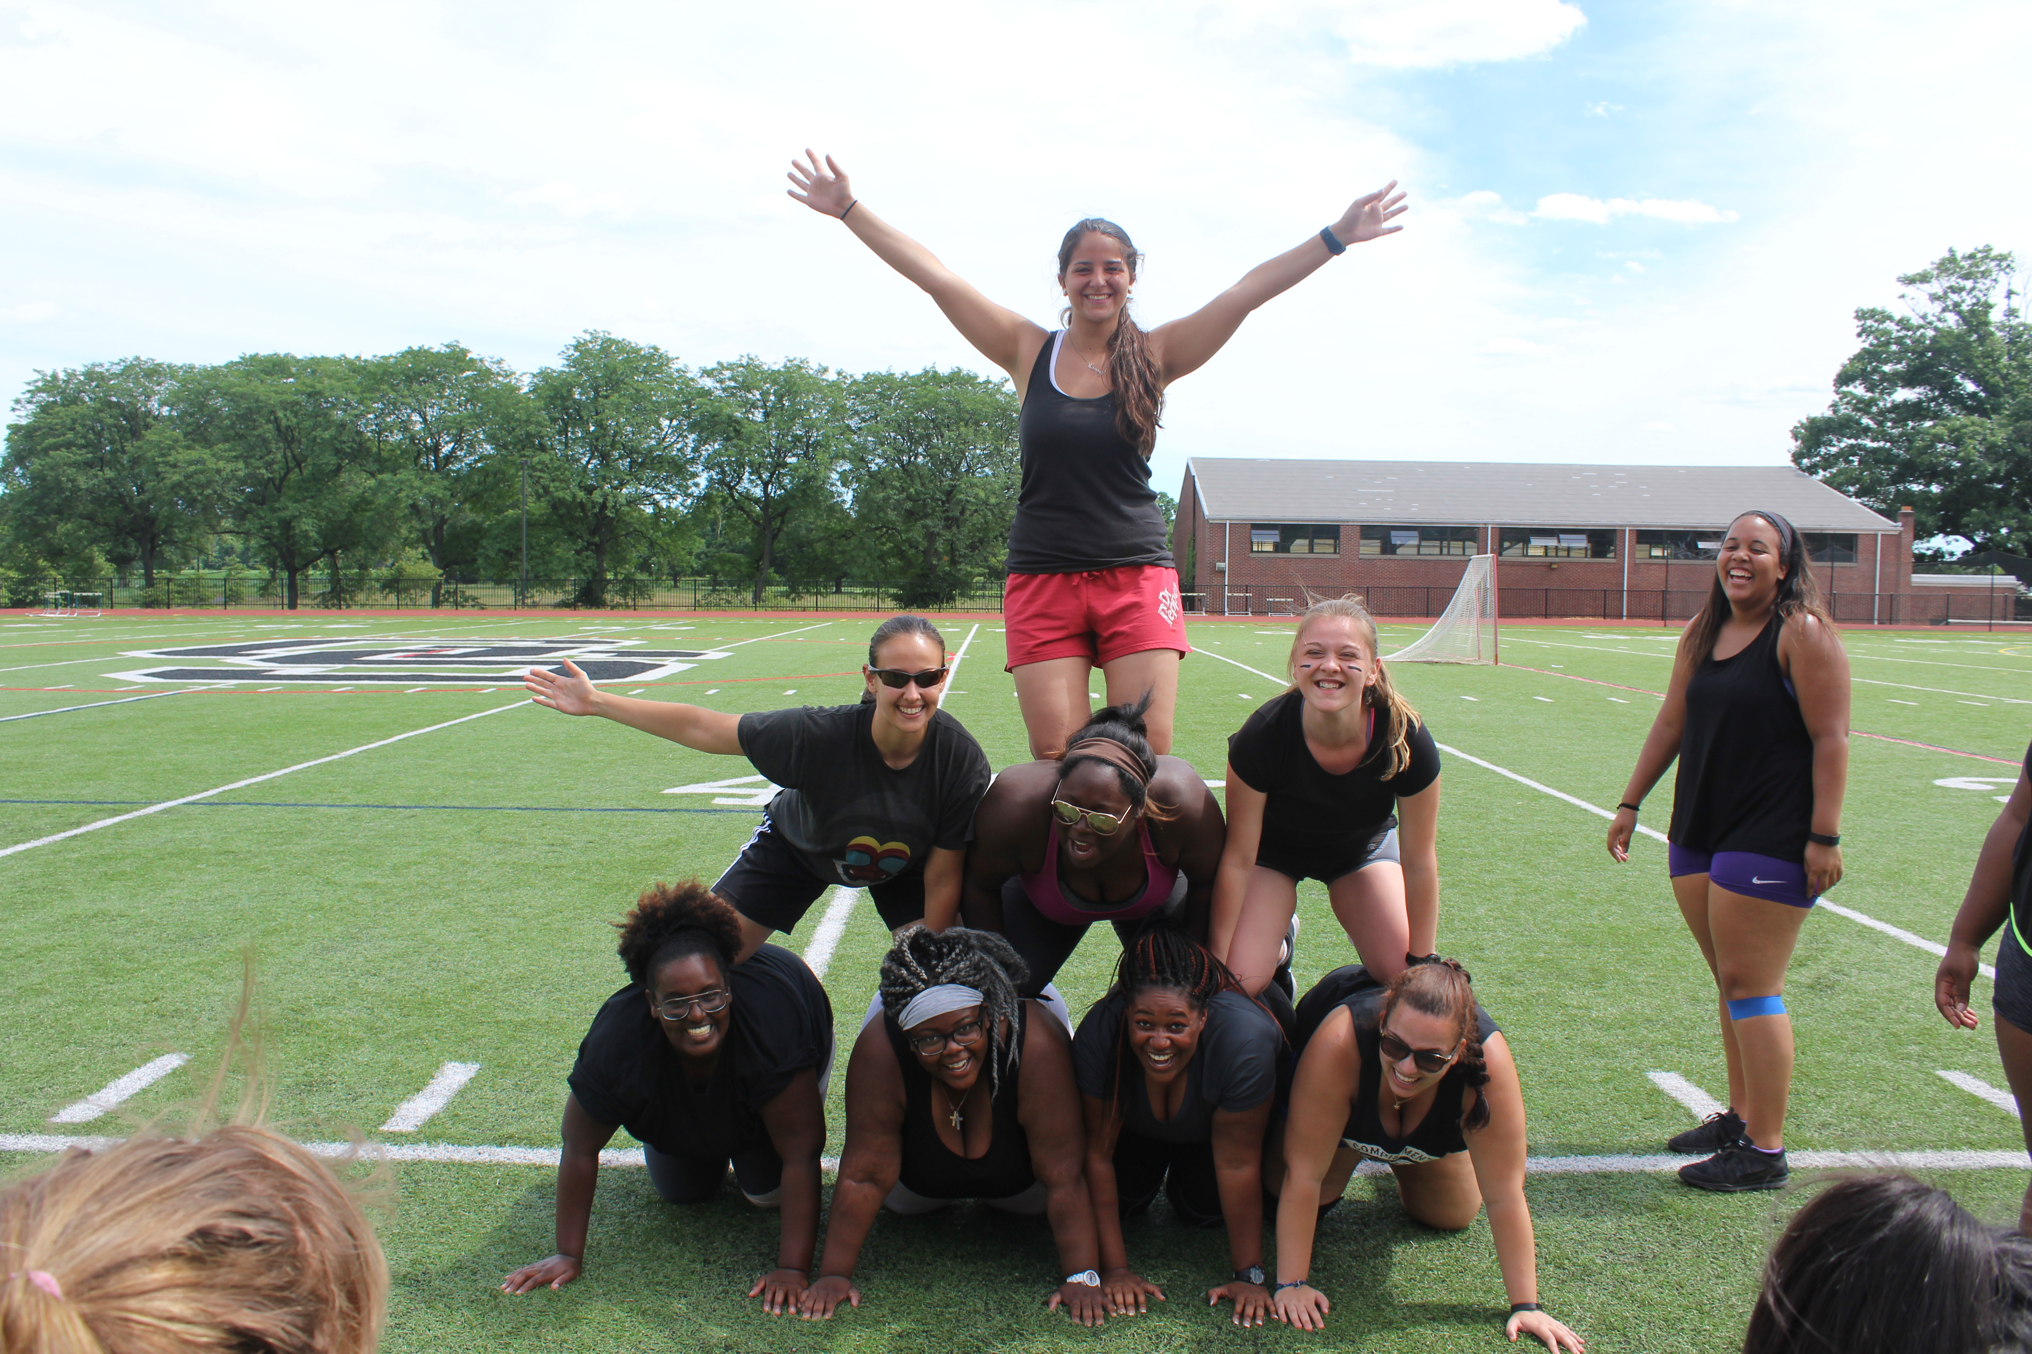

THE BIG SHOW
In 2019 we produced a wonderful version of Broadway Princesses. Please let us know which show you would like to see performed at camp. The show is on Friday July 17th, and the following day we create the highlights for the parents on visiting day!

STAFF RETURNING
We really are a family at Camp Pennbrook! Most of our key staff and specialists will be returning. In addition, most of our best counselors are planning to return and some of our junior counselors will be moving up to full counselor status!
CARDIO/ZUMBA: Savannah, Atrice and Amanda
ART: Cheryl
TENNIS: Patrick
DRAMA: Kristin
SPORTS/BOOT CAMP: Joel
HEAD DIETITIAN: Lisa
NURSES: Ruth , Sara and "Nurse Sam"
COUNSELORS: Brooke Rainville, Carrington Johnson, Nasya Miles, Sarah Rothchild, Amanda Morach, Adira Clark

Tennis/Horseback Riding/Personal Training
Once again Camp Pennbrook will be offering additional services for those campers that are interested. Marc will be returning for his third summer at camp to teach semi private and private tennis lessons. This year at The George School we have the horse stables on site. Campers may enroll on semi private rides as well as private rides.
The George School Personal Trainers will be providing training services for those campers that are interested. Sessions will be semi private as well as private.

Why Camp Pennbrook? From our campers questionnaires!
“You get to meet new people and see old friends”
“Everyone is working towards the same thing”
“There is no judging and everyone is very accepting”
“It showed me how to eat better and feel better “
“It taught me to be myself and live a healthier lifestyle!”

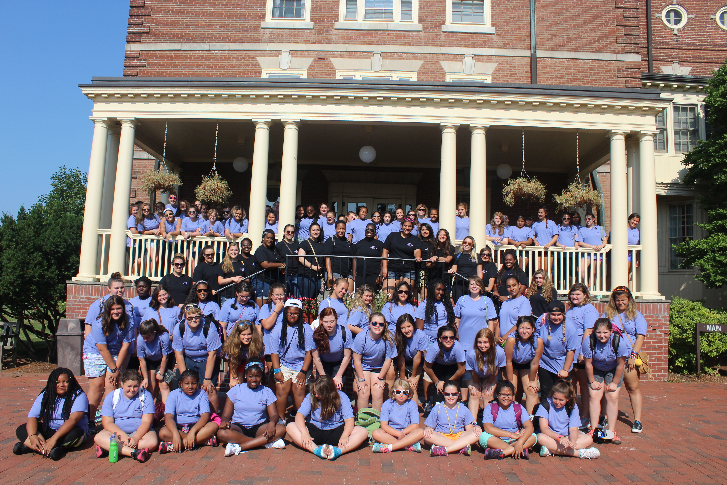

New Parent Program For Moms
Due to popular demand, many moms have inquired about attending camp so that they can lose weight and get all of the benefits for the program. It also helps them learn about our program so that they can help their daughter follow along after camp is over.
In past years, we have permitted the moms of their campers (and their friends) to attend camp after August 1st for either a long weekend or the last week. This year we now have a new air-conditioned dorm set aside for our moms to reside with our adult staff. Moms may register for either a long weekend or a stay or one week or mom anytime during the summer.
They can join in at daily cardio classes, attend rap sessions and cooking classes with the nutrition team and take advantage of some of the camp sports, evening activities, and trips. The program can be as structured or non-structured for the moms individual preference. Some moms go out to the malls and local attractions in the afternoon but have all o3 of their meals at camp. They also will have the option to go on our special trips to Broadway shows, shopping in New York City, and buy new clothes at King of Prussia Mall at the end of the season

Please call for details on this new expanded program!

