Camp Pennbrook June 2020 Newsletter
Upcoming Events
Opening Day
July 12th
Last Day
August 8th

Dear Parents,
Hope everyone is well and safe. It certainly has been an unprecedented Spring with all the recent current events. However, all of our campers and staff are excited to attend camp. Since everyone has been home for the past 3 months, camp is extremely important this year in getting everyone back out in the fresh air, working out and eating healthy.

We are in the process of trying to organize our camp program for this summer with the new guidelines. We are waiting for the Governor of Pennsylvania to provide the dates for the "Green" reopening phase required for camps. Since we anticipate it will take several more weeks to reach that phase, we have moved our first day of camp to July 12th.

In that regard, all campers must arrive on that date and can enroll for any period for 2, 3 or 4 weeks. Our daily program should be pretty much the same factoring in new protocol and guidelines from the American Camp Association who is working with the CDC as well as the governor. The one change is that we will be unable to run any off-campus trips, and all of our major trips to concerts and shows were already canceled.

We should know within the next 1-2 weeks if the dates for camp and the guidelines will enable us to operate, our number one priority is the health and safety of our campers and staff.

Accordingly, if you are interested in attending camp, we must hear from you before June 15th as enrollment will be limited by the new social distancing guidelines. you can send a $500 deposit which is fully refundable, or just confirm you are interested in attending and we will bill you later.
You will note we are offering a special year end rate of $1100 per week.

Please call or email with any questions,
Flip Shulman
Director

Revised 2020 Dates & Rates
Regular rate Year-End special
session 1 6/20-8/8 (49 days) X X
session 2 6/20-7/12 (22 days) X X
session 3 7/12-8/8 (27 days) $5550 $4400
session 4 7/12-8/1 (20 days) $3900 $3300
session 5 7/12-7/26 13 days) $2725 $2200
*Additional weeks are at the rate of $1100 per week
*Dates subject to change based on state and CDC guideline

2020 Activities
Talent Show
Karaoke Dance Parties
Ms. Pennbrook
Drama Production
Master Chef
Name That Tune
Counselor Hunt
Capture the Flag
Color Run
Apache Relay
Running Charades
Sing Down

Returning Staff
We really are a family at Camp Pennbrook. This year your "camp family" will become an important part of your experience to guide you through the new protocol and procedures being implemented.

Group Leaders: Heather Burns, Rhina Allende
Cardio: Savanna Barris, Atrice (Zumba)
Art: Cheryl Wilks
Drama: Kristin Smith
Dietitian: Lisa Scherer

Most of our counselors are former campers. Those planning to return are Brooke Rainville, Carrington Johnson, Maycee Campano, Nasya Miles, Malorie Iovino, Sarah Rothchild.
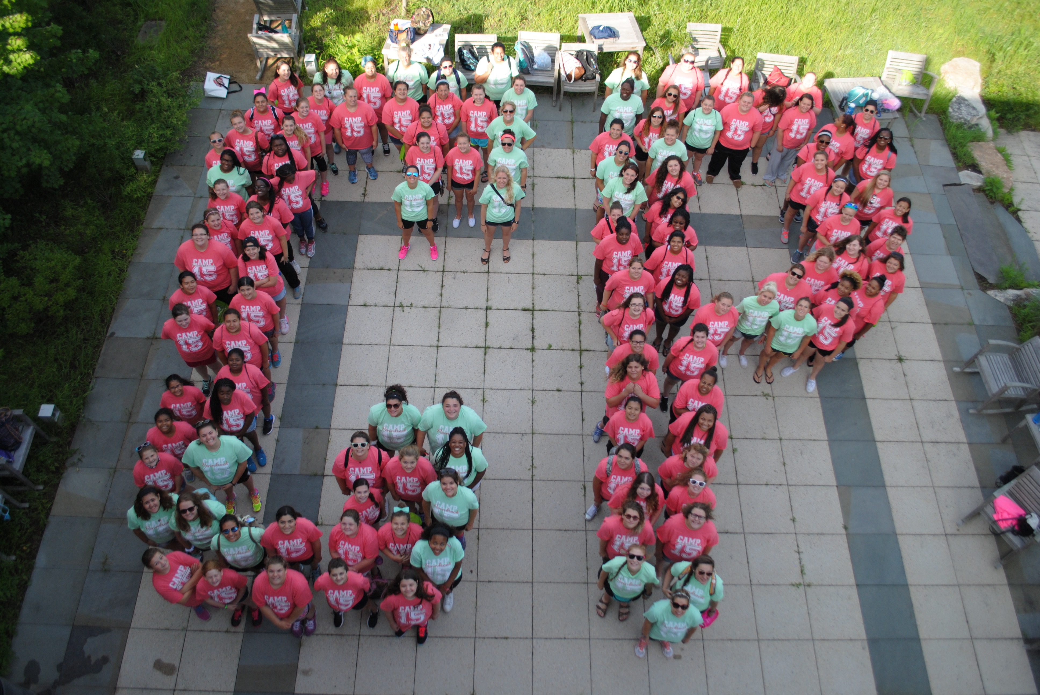

Camp Store “Be there or be square”
We already started to order new merchandise for our camp store this summer. So far we are planning to order tank tops, long sleeve, hoodies, sweat pants, back packs, water bottles as well as pinnies. Let us know if you have any merchandise you would like to see at the store. So far campers have suggested: pajama pants, soffee shorts, sunglasses and blankets!

Program Highlights For 2020
- CARDIO WITH SAVANNA
- ZUMBA WITH ATRICE
- RAP/NUTRITION CLASSES WITH LISA
- COOKING CLASSES
- DRAMA AND IMPROV WITH KIRISTIN
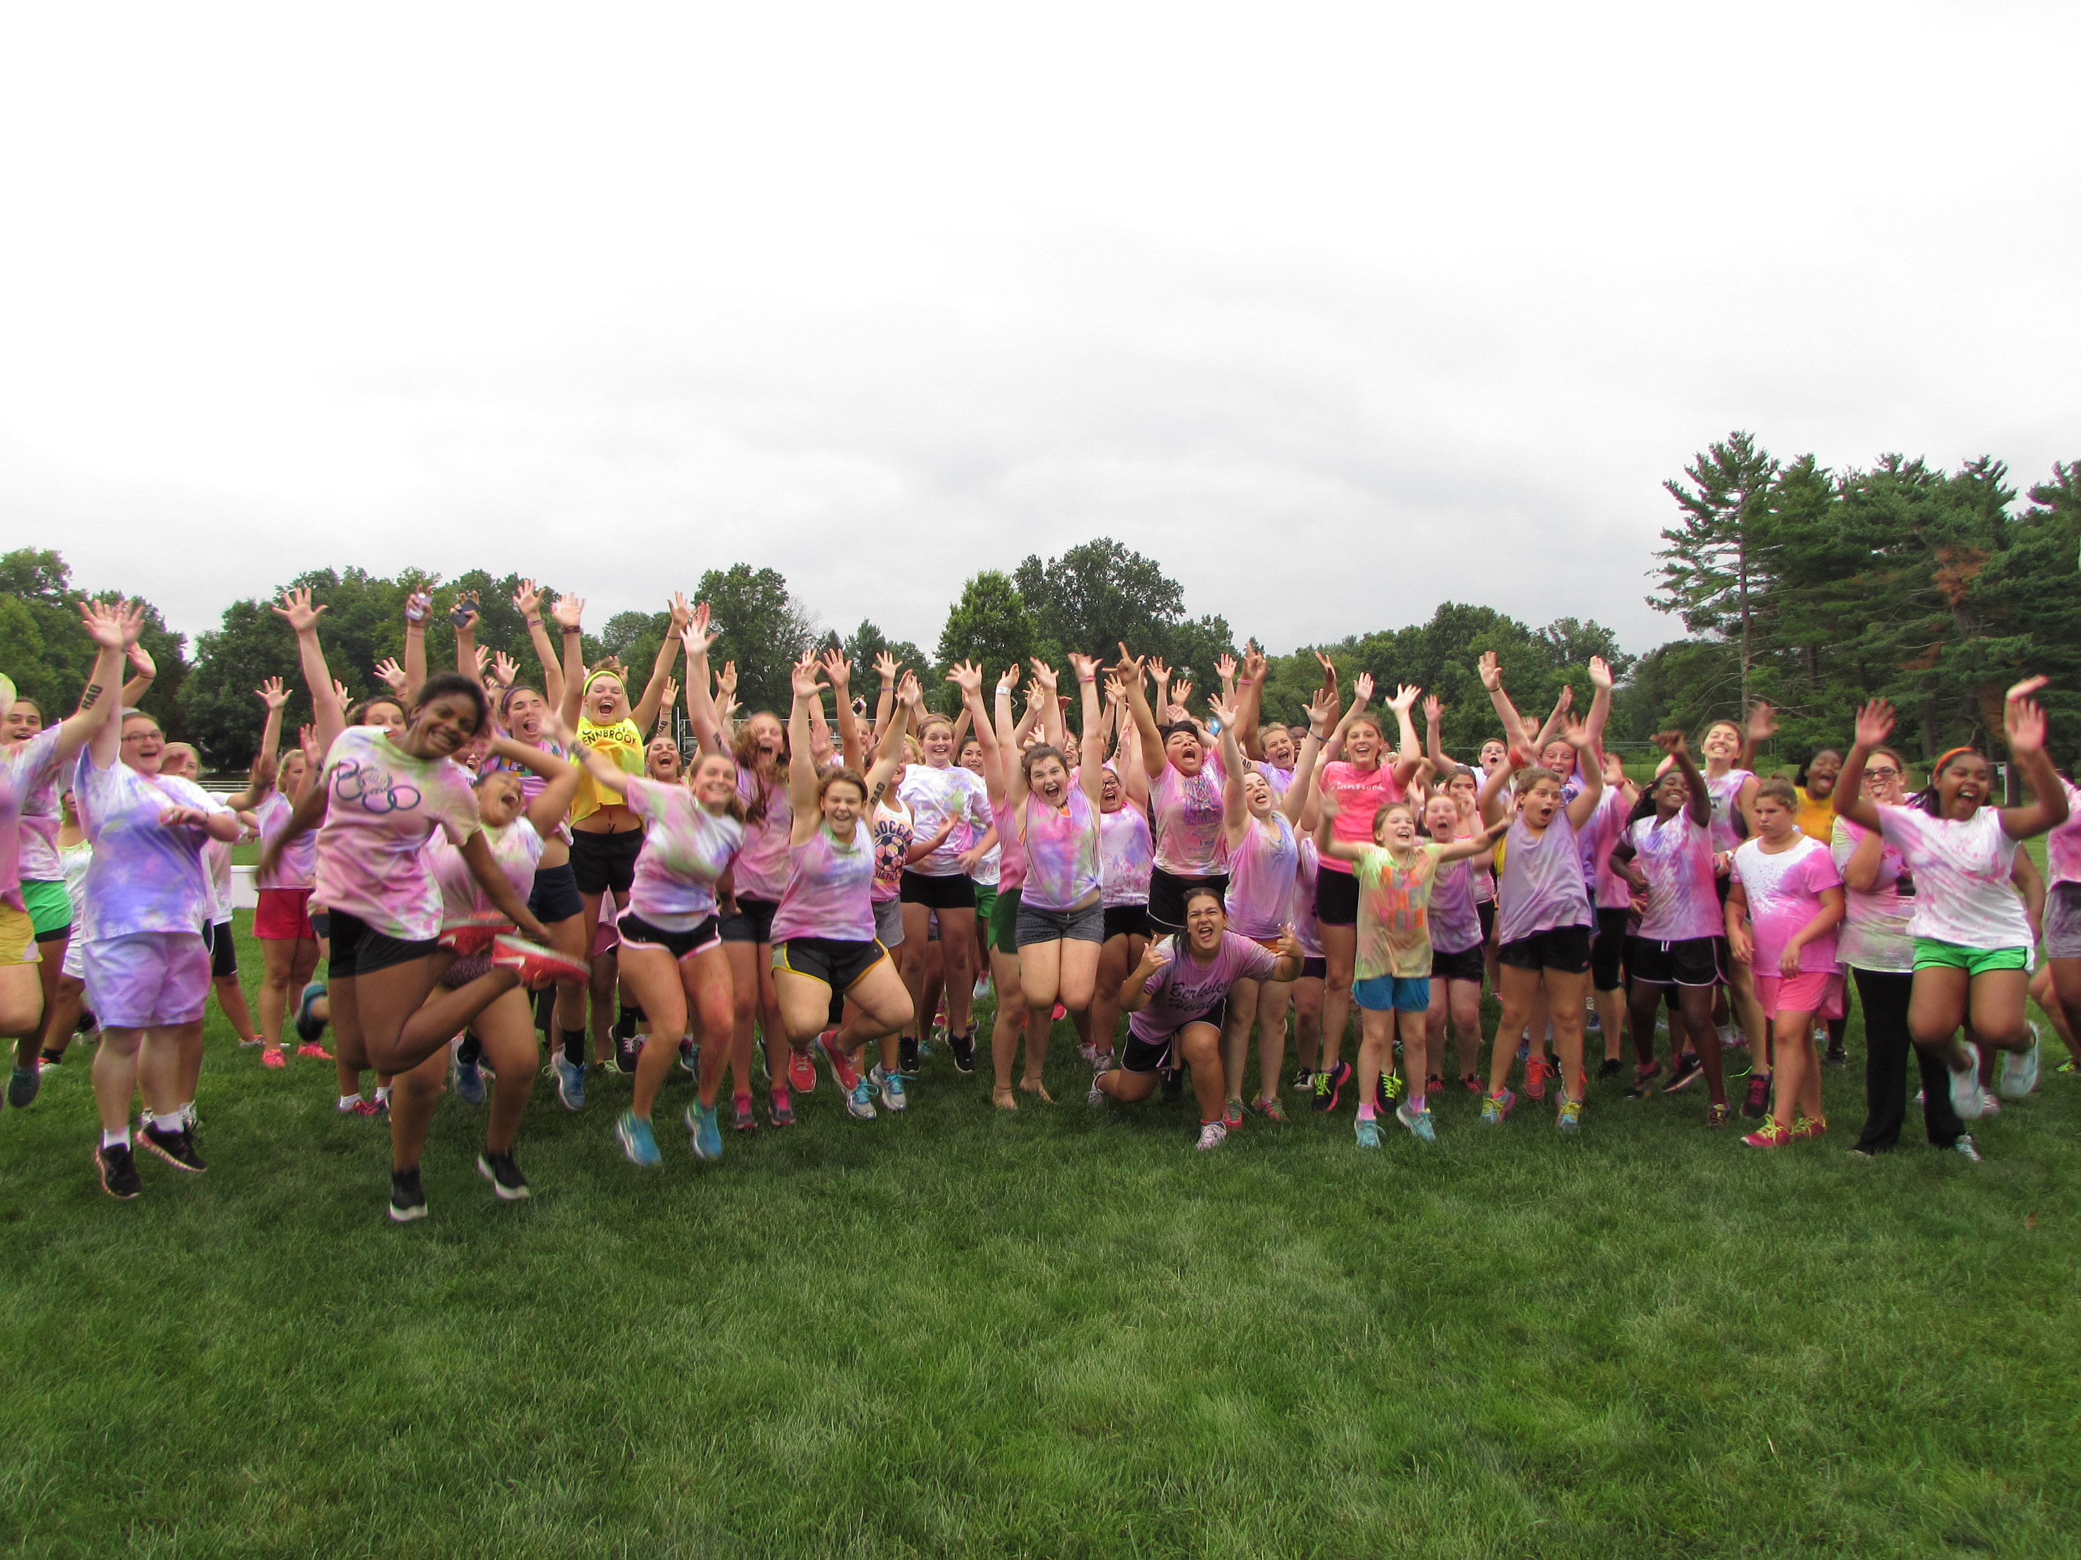

Private Tutoring
Our staff will be offering tutoring in most math and reading levels, SAT prep etc. In addition, arrangements can be made for any online classes required while at camp. Staff will supervise campers in a classroom setting which will not take away from any core activities at camp.

