 C:\Users\Philip\AppData\Local\Microsoft\Windows\Temporary Internet Files\Content.IE5\DIPBL175\MC900089034[1].wmf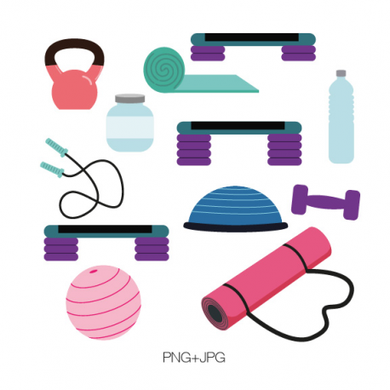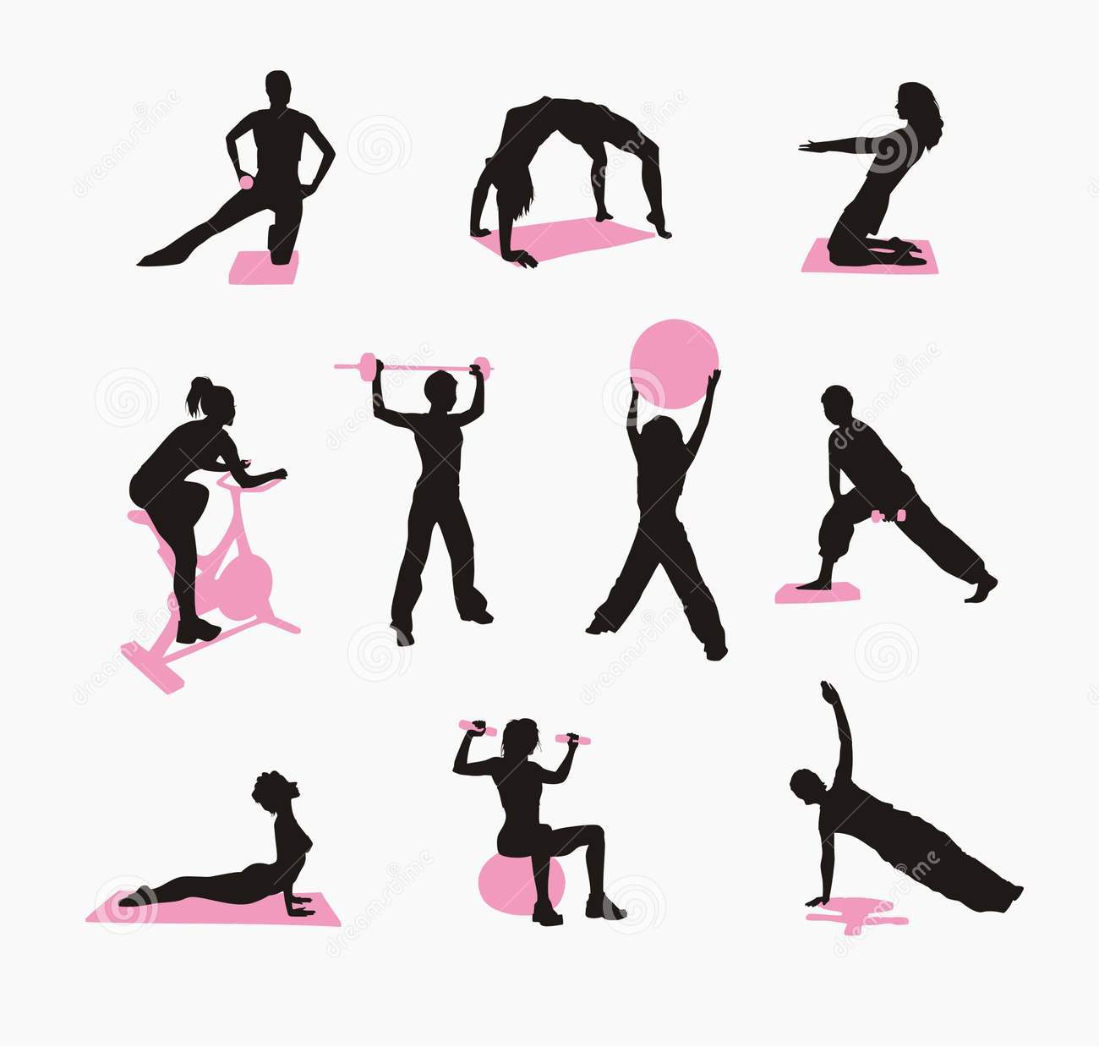

## Summer Activities

Hi Girls, how are you? Can you believe its already March! It’s crazy how fast the winter is going and before you know it will be time to go back to camp! We are excited to be returning to The George School. Many of our key staff are returning to camp for what will be an unbelievable summer. Let’s say goodbye to winter and get back into our summer routines.  
  
Remember, it’s all about a lifestyle change. Our nutrition team is preparing for camp under the direction of Tori Kuebler who is back planning our menus and recipes while serving as a consultant. The team is planning great new rap session topics, cooking demonstrations and one-on-one nutritional counseling sessions. We remember the things we cover in camp and throughout the year as well as the rest of our lives!

Many of our key staff are planning to return including Cindy Argow, Alyssa Granger and Katie Hoover. Patrick is back running tennis and Savannah is returning as our main cardio instructor. Our 2020 counselors are almost all ‘homegrown’ and have been campers for anywhere from 3-7 years. They include Natalie Lamanna, Zoey Wheeler, Katelyn Fass, Malorie Iovino, Mary Freeze, Emma Sellers, Daphney Milord, Erica Pramer and many others. We truly are a family at Camp Pennbrook.

We also have many new and exciting activities and great trips to broadway shows and concerts on the schedule which are listed in this newsletter. We can’t wait to see you this summer!

-Flip, Nikki and the Pennbrook Staff

This summer is shaping up to be a great one. We have already booked some of your favorite activities:

* Game show Man
* Karaoke/ dance parties
* Bowling / Laser Tag
* Movies at the Multiplex
* Eric Wilzig Magic Show
* Ice Skating
* Beach
* Day at the Beach at the Jersey Shore

We are still looking for new activities and entertainment to make sure each and every one of you has the best time at camp.

Feel free to email us any ideas or activities you would like to see at camp!

# Hello!

Attention new parents and campers!!! Be sure to set aside one of the following dates when you can tour the beautiful facilities of Camp Pennbrook and meet most of our key staff members and new campers. Refreshments will be served.

Save the date: **April 19th** or **May 17th!** **12-4 PM**

For questions or concerns don’t hesitate to contact us. Please RSVP today by calling 1-800-442-7366 or email Camppennbrook@att.net.

## Open Houses

Camp Pennbrook March Newsletter

March 2020

We are busy booking the best trips for the 2020 summer. So far, we have booked:

BROADWAY:

* MRS. DOUBTFIRE
* MOULIN ROUGE

CONCERTS:

* HARRY STYLES
* JUSTIN BIEBER
* MAROON 5

## 2020 Trips

## New Parent Program For Moms

Due to popular demand, many moms have inquired about attending camp so that they can lose weight and get all of the benefits for the program. It also helps them learn about our program so that they can help their daughter follow along after camp is over.

In past years, we have permitted the moms of their campers (and their friends) to attend camp after August 1st for either a long weekend or the last week. This year we now have a new air-conditioned dorm set aside for our moms to reside with our adult staff.  Moms may register for either a long weekend or a stay or one week or mom anytime during the summer.

They can join in at daily cardio classes, attend rap sessions and cooking classes with the nutrition team and take advantage of some of the camp sports, evening activities, and trips. The program can be as structured or non-structured for the moms individual preference. Some moms go out to the malls and local attractions in the afternoon but have all o3 of their meals at camp. They also will have the option to go on our special trips to Broadway shows, shopping in New York City, and buy new clothes at King of Prussia Mall at the end of the season

Please call for details on this new expanded program!

We still have limited openings for current and alumni campers who would like to be CITS (Counselors-in-training) or JCs (Junior Counselor). These are the training programs for becoming a full-fledged counselor. You must be 15 or 16 to be a CIT and 17 or 18 to be a JC. CITs can attend for 3 weeks or longer but JCs must attend for either 4 weeks or the full 7 weeks. Both positions involve a great deal of responsibility and also afford you a reduced tuition. You would still have a chance to work out everyday and participate in all the sports and activities. Call for details.

## Junior Counselor and Counselor-in-Training

## Dramatics: “The Big Show”

We are already starting to get suggestions for this year’s big show. Last year we did a wonderful version of Broadway Princesses and in prior years we have done “Hairspray”, “The Little Mermaid” “Charlie Brown” and “Bye Bye Birdie” So far the suggestions we have are “The Wizard of Oz”, “The Sound of Music”, “The Lion King” and “Aladdin”. The show is on Friday July 17th. Email or call us with your ideas our upcoming summer production!

This summer we will again have weekly RAP classes along with re designing the new course.

Campers will get to learn about our camp meal plan and why it works, they will also learn how to properly balance meals at home as well as choosing wisely when it’s time to snack. These are just a few of the topics that will be covered.

## New RAP Sessions

-Try to get at least 30 minutes of cardio in today! Dedicate these 30  
minutes to yourself and your health.  
  
-When you feel like giving up, simply look back on where you started  
and how far you have come. It's all worth the work!  
  
-Tired of the same workout routine? Try something new to keep you  
interested and moving. Research new workouts online, ask a personal  
trainer, or follow exercise accounts on Instagram for inspiration of  
new workouts to try.  
  
-Cardio and strength training are BOTH important. Try your best to  
incorporate both into your workout routines.

**We are pleased that Michelle will be back with her great Boot Camp and we are delighted to introduce our new Zumba instructor, Gabby Mason. Gabby is from Ohio and currently attends the University of Kentucky. She can do body blast, upper and lower body and can teach volleyball and also will teach Zumba Water Aerobics.**

## March Workout Tips!